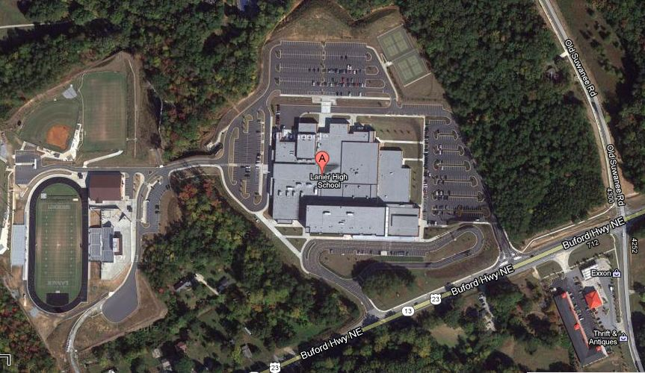

**Tennis Courts**

**All Patrons**

**Enter Here**

**Visitor**

**Parking**